Test Case: tc003_SPX_Dev5_Crear_Requisicion_Spot_Tipo_Cobro_CC_Urgent
Step 1 - Enter username and password and click to button Enter : Credentials Entered
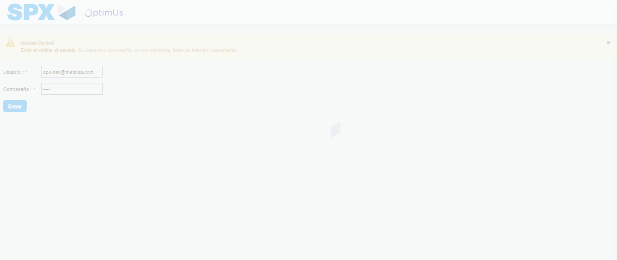Image file-name: QC_Testing-tc003_SPX_Dev5_Crear_Requisicion_Spot_Tipo_Cobro_CC_Urgent-1782242607533

Step 2 - Select to UEN and Access to Spot Buy Requisitions : UEN Correctly selected and Correct access
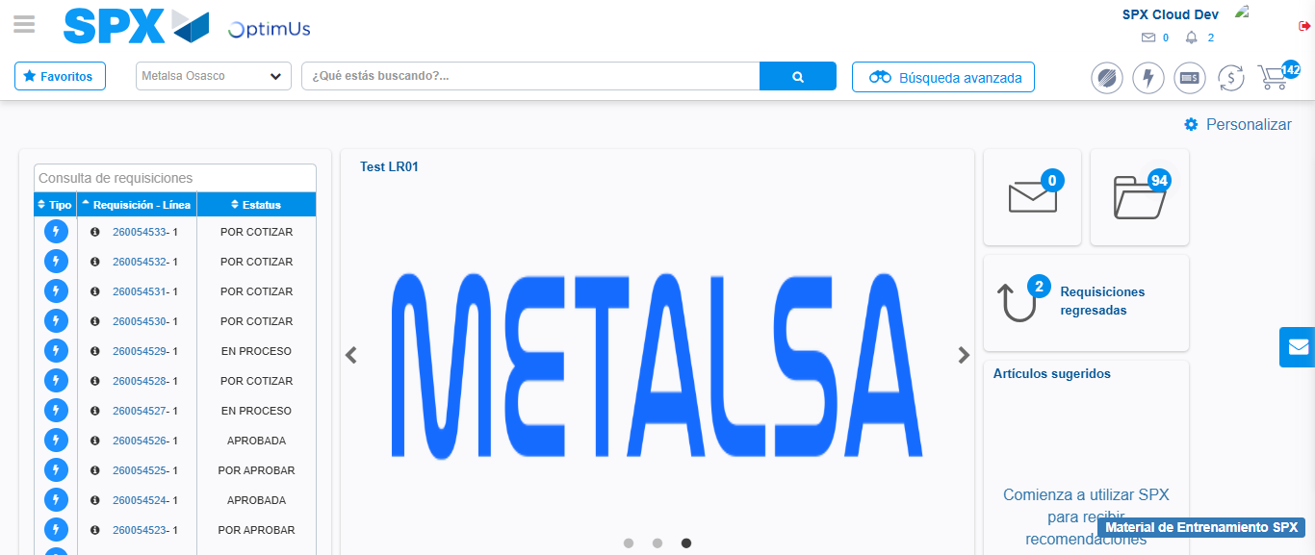Image file-name: QC_Testing-tc003_SPX_Dev5_Crear_Requisicion_Spot_Tipo_Cobro_CC_Urgent-1782242694823

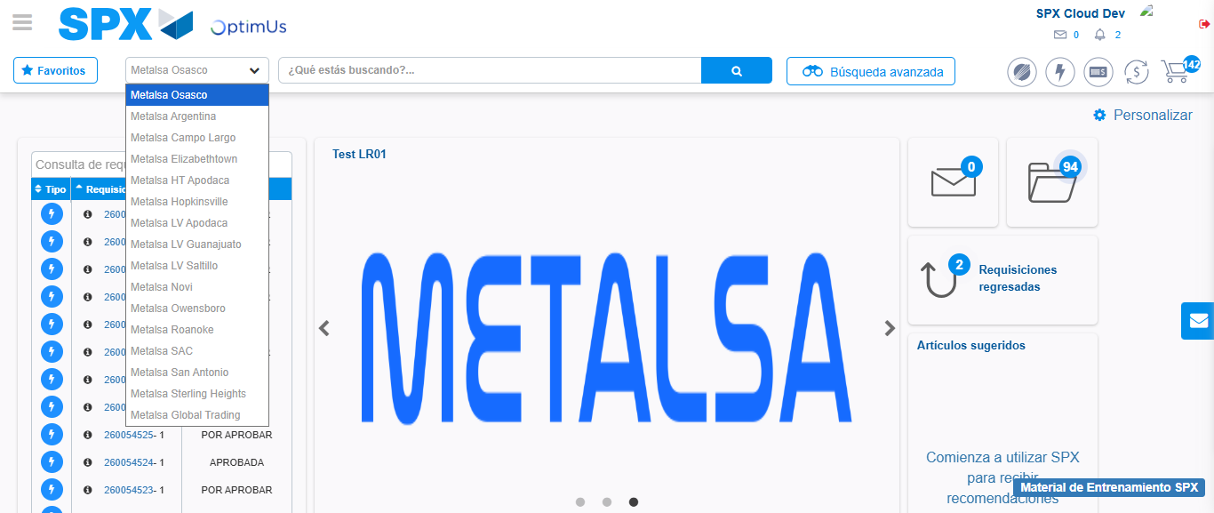Image file-name: QC_Testing-tc003_SPX_Dev5_Crear_Requisicion_Spot_Tipo_Cobro_CC_Urgent-1782242697564

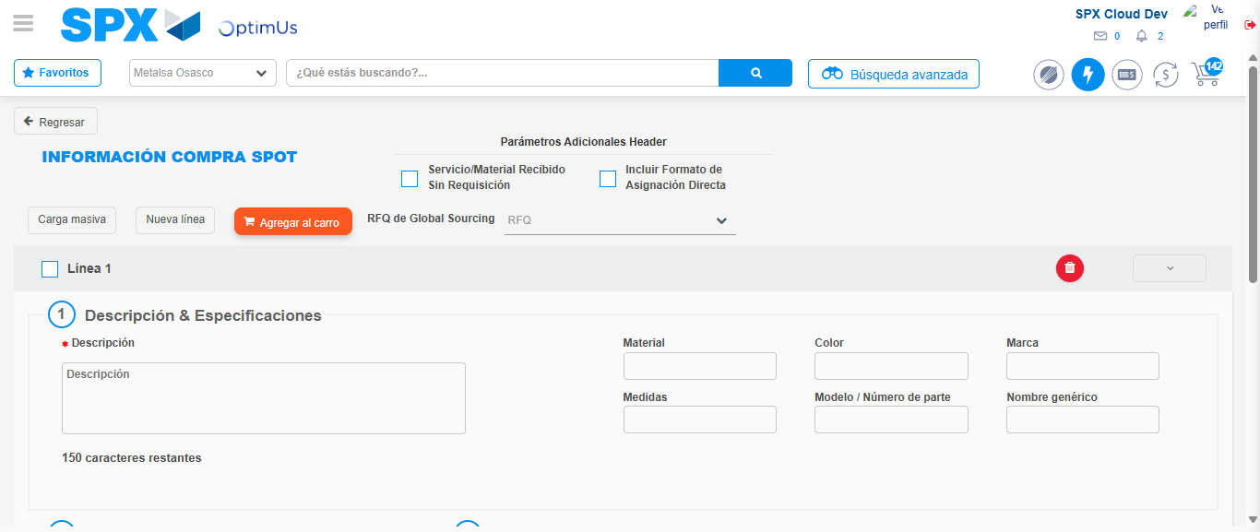Image file-name: QC_Testing-tc003_SPX_Dev5_Crear_Requisicion_Spot_Tipo_Cobro_CC_Urgent-1782242705104

Step 3 - Data Capture Spot Buy Requisition: Data captured correctly
Image file-name: QC_Testing-tc003_SPX_Dev5_Crear_Requisicion_Spot_Tipo_Cobro_CC_Urgent-1782242705405

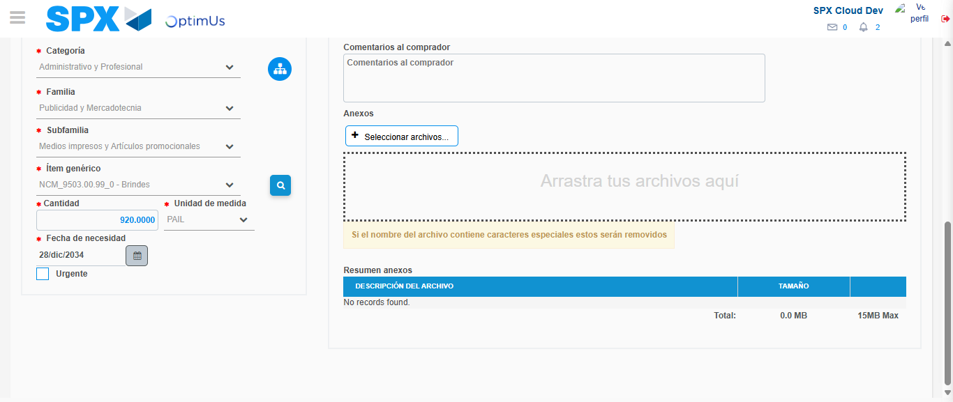Image file-name: QC_Testing-tc003_SPX_Dev5_Crear_Requisicion_Spot_Tipo_Cobro_CC_Urgent-1782242718740

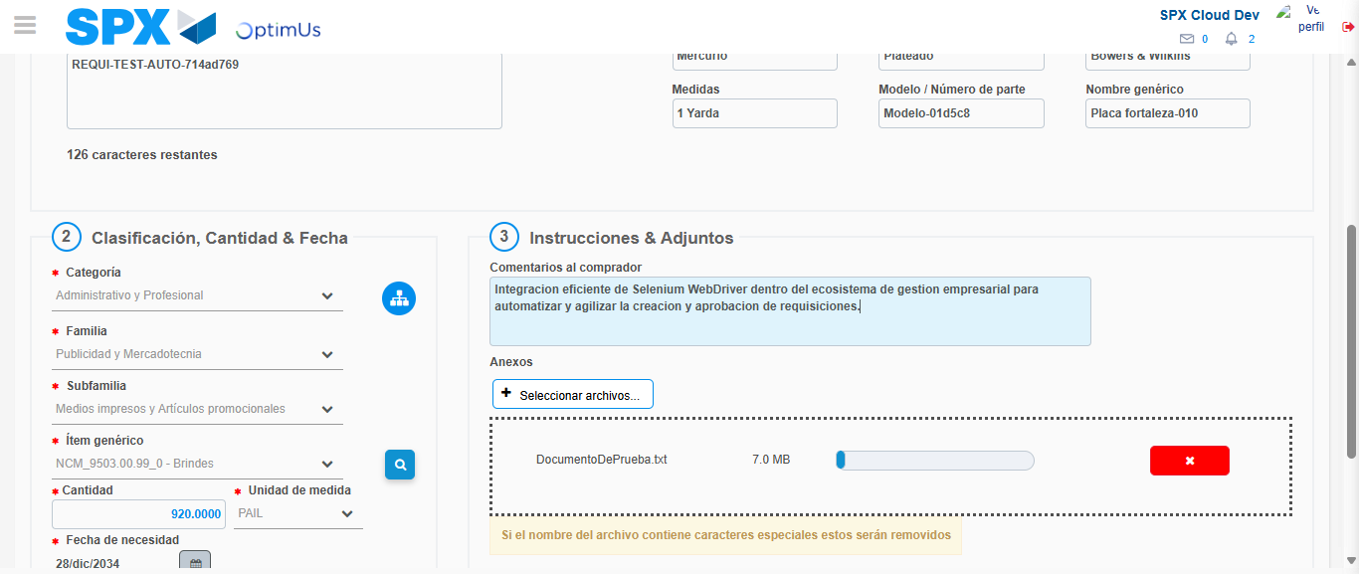Image file-name: QC_Testing-tc003_SPX_Dev5_Crear_Requisicion_Spot_Tipo_Cobro_CC_Urgent-1782242719658

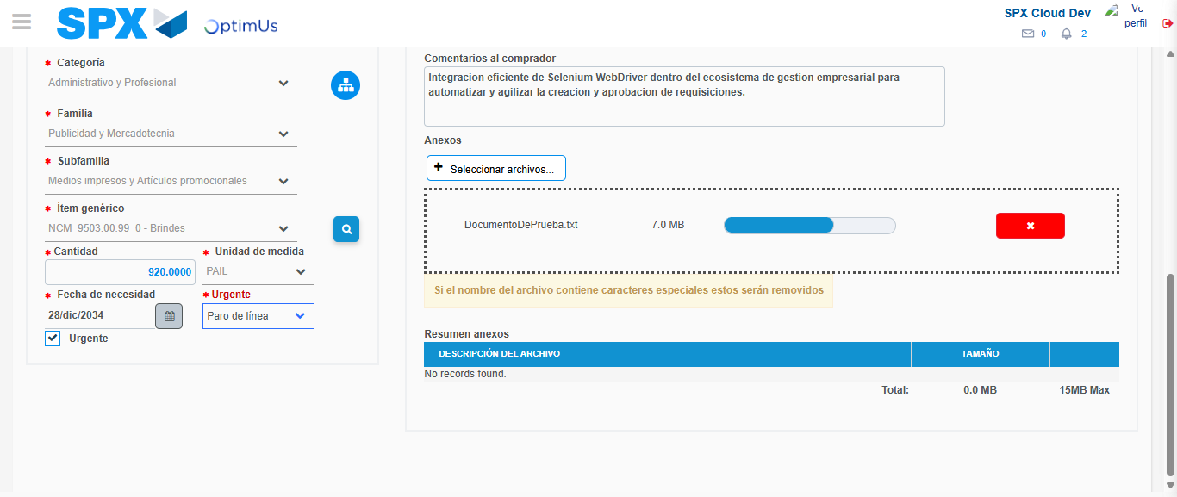Image file-name: QC_Testing-tc003_SPX_Dev5_Crear_Requisicion_Spot_Tipo_Cobro_CC_Urgent-1782242723577

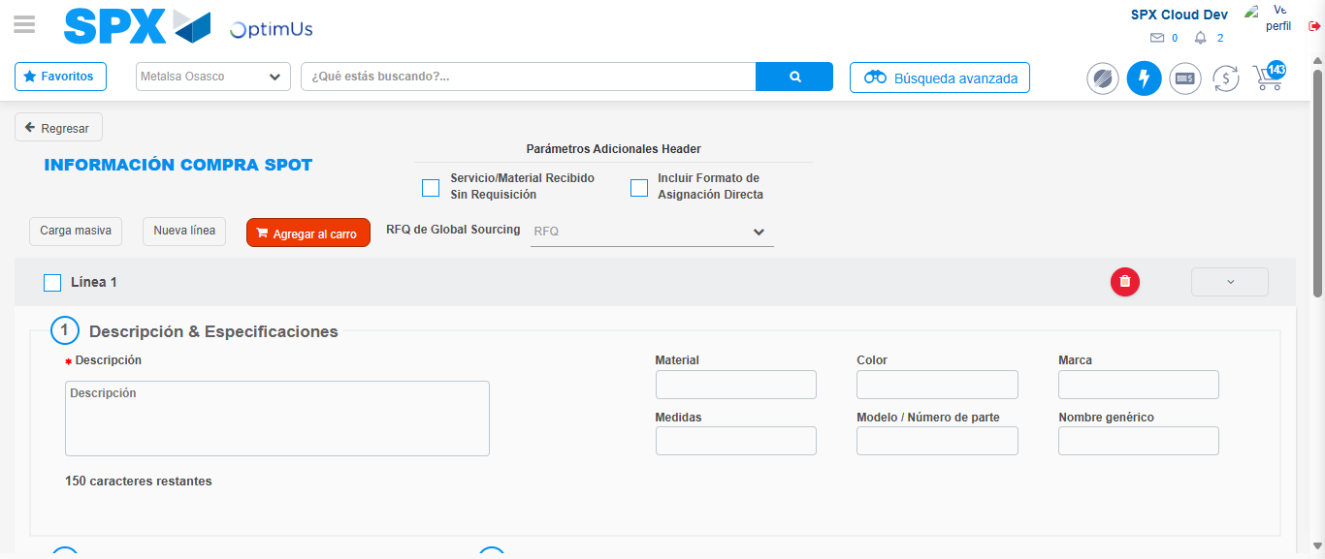Image file-name: QC_Testing-tc003_SPX_Dev5_Crear_Requisicion_Spot_Tipo_Cobro_CC_Urgent-1782242731818

Step 7 - Return to Main Page SPX : Return to Main Page SPX
Image file-name: QC_Testing-tc003_SPX_Dev5_Crear_Requisicion_Spot_Tipo_Cobro_CC_Urgent-1782242694823

Image file-name: QC_Testing-tc003_SPX_Dev5_Crear_Requisicion_Spot_Tipo_Cobro_CC_Urgent-1782242697564

Image file-name: QC_Testing-tc003_SPX_Dev5_Crear_Requisicion_Spot_Tipo_Cobro_CC_Urgent-1782242705104

Image file-name: QC_Testing-tc003_SPX_Dev5_Crear_Requisicion_Spot_Tipo_Cobro_CC_Urgent-1782242734105

Image file-name: QC_Testing-tc003_SPX_Dev5_Crear_Requisicion_Spot_Tipo_Cobro_CC_Urgent-1782242734311

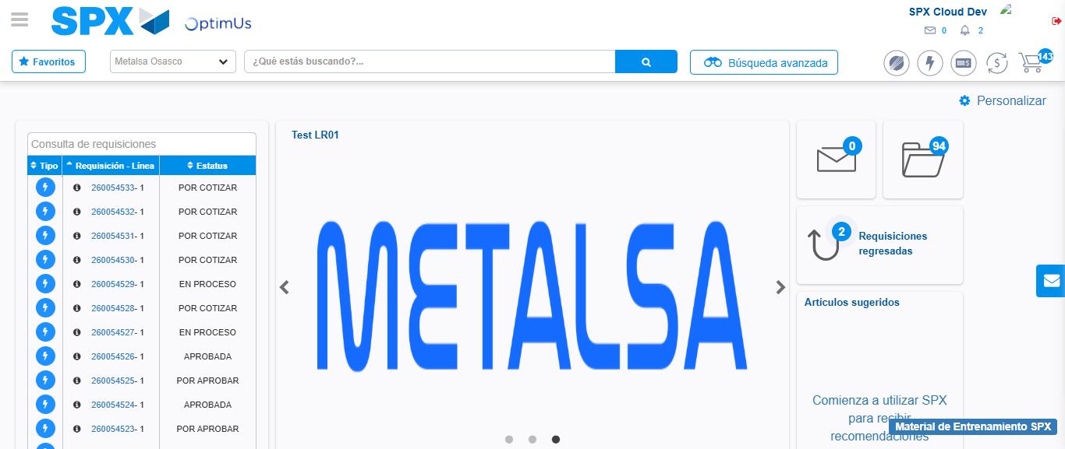Image file-name: QC_Testing-tc003_SPX_Dev5_Crear_Requisicion_Spot_Tipo_Cobro_CC_Urgent-1782242755880

Step 8 - Log Out : Log Out SPX
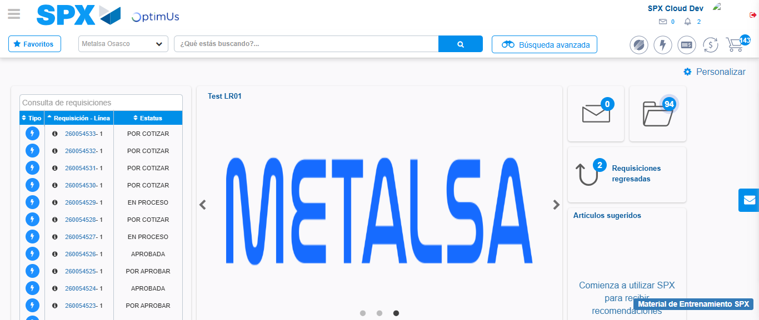Image file-name: QC_Testing-tc003_SPX_Dev5_Crear_Requisicion_Spot_Tipo_Cobro_CC_Urgent-1782242756274

